Press Release Sculpteo
Paris and San Leandro, June 5, 2018

Sculpteo, the fastest and larger 4.0 factory!
To meet the increasing demand, Sculpteo develops its HP Multi Jet Fusion machine park and becomes the largest 3D manufacturing factory in France integrating this technology

Sculpteo, leader in online 3D printing and digital manufacturing, is pleased to announce that it acquired a new unit integrating the HP Multi Jet Fusion to ensure the manufacturing of 3D printed parts in record time. Sculpteo therefore becomes the largest machine park on the HP Multi Jet Fusion technology in France, amongst the most important worldwide. Professional 3D printing confirms a growth of 25% in 2017, reaching nearly 7 Md€ by 2020.

Sculpteo, Driving Force of the 4.0 Revolution
In the advent of industry 4.0, the demand of 3D printed objects increases at the highest pace. To meet this demand, Sculpteo has acquired a third HP Multi Jet Fusion printer, making it the largest machine park in France on this exclusive technology. The HP Multi Jet Fusion 3D printing solution allows to efficiently address the needs of industrials to manufacture functional prototypes, small or medium series of final parts, machines, and spare parts. Therefore, Sculpteo acquires capabilities that are essential to its clients and to the market needs: more agility, speed, quality, customization, at a better price.

For Clément Moreau, CEO et co-founder of Sculpteo, “The digital transformation in the industrial sector today is a reality! With the acquisition of a third HP Multi Jet Fusion printer, we show that on-demand manufacturing can adapt to the new requirements of agility, quality and speed offered by the new HP Multi Jet Fusion technology. They are the key to building a truly optimized manufacturing process where everything is possible!”
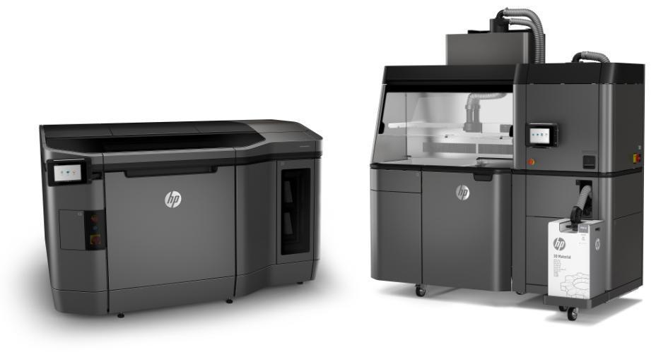
The HP Multi Jet Fusion Technology The HP Multi Jet Fusion 3D Printing technology works as follows. A printhead selectively drops fusion agent microdrops on a powder bed, then an infrared lamp fusions the parts penetrated by the fusion agent. The use of printheads associated to lamps allows to significantly accelerate the manufacturing speed by making it independent from the surface to fusion (contrary to the processes based on laser). The procedure used is far less aggressive with the powder which is also easier to recycle. HP has also developed a proprietary system of rapid cooling of the parts after printing, as well as an automated recycling station for the powders and the supply units, thus allowing a high productivity of the system.

For now, this technology allows to print parts in grey and black, in polyamide PA-12 (Nylon), a solid and flexible plastic. Other options will be unveiled in the next months.

“We are particularly proud for the faith that Sculpteo continues to have in us. HP has the objective of developing its exclusive 3D printing technology to offer companies an essential link to the new industrial revolution. Our strategy relies entirely on an exceptional ecosystem of partners and clients that are experts in their field, to make evolve the way to conceive and manufacturing objects. HP and Sculpteo share this same vision”, says Joana Mayeur de Medina, 3D Printing business manager at HP France.

About Sculpteo
Sculpteo, pioneer and specialist of digital manufacturing, offers a service of online 3D printing, from 3D model transfer to the order of the object, and wants to make this technology easy and accessible to all. Based in San Francisco and Paris, Sculpteo offers on-demand 3D printing and manufacturing in large scale for start-ups, SMEs and design studios. The offer of Sculpteo resembles more than 100 combinations of materials with multiple colors and finishing options, as well as a technical analysis and superior repair of files. The Sculpteo factories use professional 3D printers and laser cutters with a very fast execution and a global delivery. Sculpteo was created in 2009 by Eric Carreel and Clément Moreau.

For more information: www.sculpteo.com

About HP
HP Inc. develops technologies to enhance everyday life, anywhere in the world. Thanks to our portfolio of printers, computers, mobile devices, solutions and services, we create unprecedented experiences.

http://www.hp.com

June 5 to 7, 2018
Sculpteo will be at Rapid.Tech + Fabcon 3.D (Berlin, Allemagne)
and at 3D Print Exibition (Lyon, France, booth E14)
http://www.rapidtech-fabcon.de/
http://www.3dprint-exhibition.com
Press Contacts
Jean-François Kitten - jfk@sculpteo.com +33(0) 6 11 29 30 28 / +33(0)9 72 33 47 63
Ilinca Spita – i.spita@licencek.com +33(0)1 45 03 21 77
Badr Rar – b.rar@licencek.com +33(0)1 45 03 21 77

Xerfi, The 3D Printing Market in the Horizon 2022, 02/03/2018. Xerfi is a French leader in sector studies.

